1. ADDITION OF 2 ARRAYS

#include<stdio.h>

int main()

{

int a[5],b[5],c[5];

int i;

printf("enter a[i]\n");

printf("enter b[i]\n");

for(i=0;i<5;i++)

{

scanf("%d",&a[i]);

}

for(i=0;i<5;i++)

{

scanf("%d",&b[i]);

}

for(i=0;i<5;i++)

{

c[i]=a[i]+b[i];

printf("c[%d] is %d\n",i,c[i]);

}

}

2.PRINT FROM 10 TO 1

#include<stdio.h>

int main()

{

int i;

for(i=10;i>0;i--)

{

printf("%d\n",i);

}

}

3.PRINT FROM Z TO A

#include<stdio.h>

int main()

{

char a;

for(a=90;a>=65;a--)

{

printf("%c\n",a);

}

}

4.SQRT

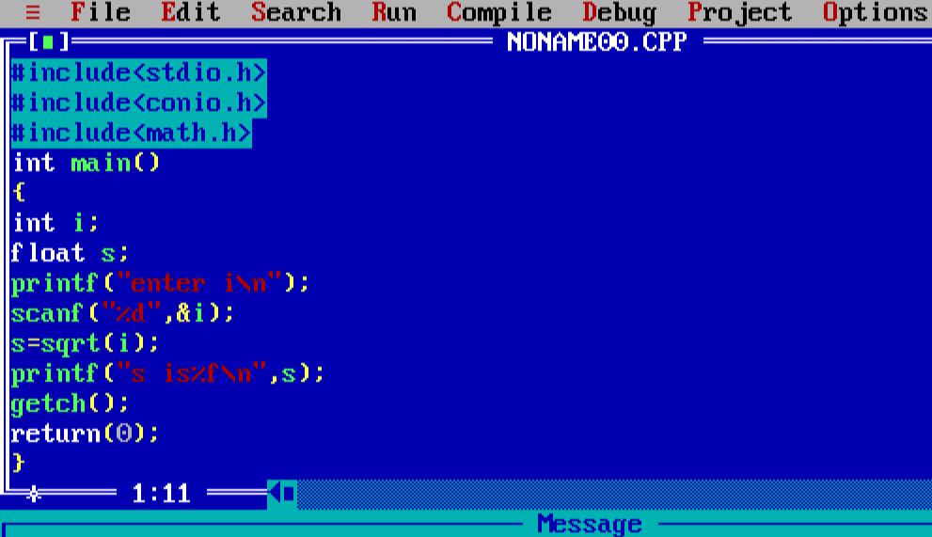

EXCERCISES:

1)Write a program in C to display the first 10 natural numbers.

#include<stdio.h>

int main() {

int i;

for(i=1;i<=10;i++)

{

printf("%d\t",i);

}

}

2.Write a C program to find the sum of first 10 natural numbers.

#include<stdio.h>

int main() {

int i,s=0;

printf("The first 10 natural number is :\n");

for(i=1;i<=10;i++)

{

printf("%d\t",i);

s=s+i;

}

printf("\nThe sum is %d",s);

}

3.Write a program in C to read 10 numbers from keyboard and find their sum and average.

#include<stdio.h>

int main() {

int i,n,s=0;

float a=0;

printf("input the 10 numbers :\n");

for(i=1;i<=10;i++)

{

scanf("%d",&n);

printf("number%d:%d\n",i,n);

s=s+n;

a=s/10;

}

printf("\nThe sum is %d",s);

printf("\nThe avg is %f",a);

}

4. Write a program in C to display the cube of the number upto given an integer.

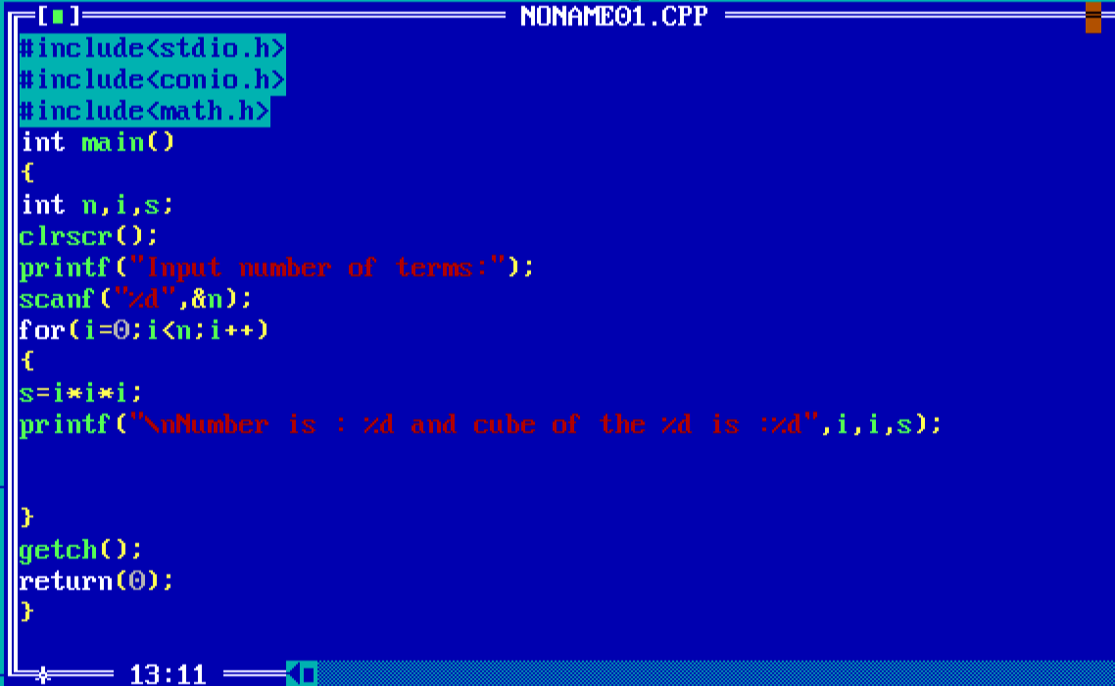

5. Write a program in C to make such a pattern like right angle triangle with a number which will repeat a number in a row.

#include<stdio.h>

int main() {

int n;

int i,j;

printf("no of rows:\n");

scanf("%d",&n);

for(i=1;i<=n;i++)

{

for(j=1;j<=i;j++)

{

printf("%d",i);

}

printf("\n");

}

}

6. Write a C program to convert a string to a long integer.

#include <stdio.h>

#include<stdlib.h>

int main(void)

{

long s;

s = atol("2222");

printf("%ld\n", s);

return 0;

}